Treasurer Handover Guide

***Special thanks to Seán O’Sullivan UL Archery Club Treasurer .***

TABLE OF CONTENTS

GETTING STARTED THE BANK MANDATE UL WOLVES WEBSITE

UL WOLVES WEBSITE - THE BUDGET GOOD TREASURER PRACTISE (TIPS)

4-5

6

7-11

12-13

14-16

### RESPONSIBILITES OF THE TREASURER

So, what are the main responsibilites of the Treasurer? To summarise them, you are the manager of the C&S bank account and online banking. But let's break this down a bit further, you responsibilites are as follows:

Changeover of the bank mandate for the C&S before/at the beginning of semester 1 (this can take some time to process, so get in there quick and get it done ASAP).

Changing the admin details for the online banking to the new Treasurer and President.

Recording of all income and expenditure on the ulwolves.ie platform/website. Uploading copies of all receipts to the online budget system.

Collection of bank statements and other post from the mailbox in the C&S office (currently upstairs in Student Life Building – C&S office, first double doors on right side, mailbox into the back right corner of the C&S office, past the offices of Lisa/Jana).

Keeping of bank documents and records in order, uploading to wolves.

Handling of the moneybox, collection of membership fees and other payments made in cash (please for the love of god avoid cash if at all possible, make use of contactless payments, Revolut, bank transfer or anything else).

* Submission of the annual budget at the end of the academic year (semester 2), without

this we will not get a budget the following year - which would be very bad for the C&S.

If C&S request an extension on your budget, you must send an email to [lisa.ryan@ul.ie](mailto:lisa.ryan@ul.ie) requesting an extension and provide the reason for the extension. Please note you must submit the budget on the deadline date set by the C&S office. *Cosmetic Edits only after the Submission Date.* The budget will be re-opened as agreed to allow additional submissions. You can follow up with an email/telephone call to Lisa about the extension. You must get confirmation email from C&S office.

### C&S COUNCIL - ADMIN SEMINAR

At the start of each academic year an Admin Seminar is held in place of the first C&S Council. C&S Council is usually held every second Tuesday from 6-7PM in the Jonathan

Swift Lecture Hall (B1-023) (it's behind the Red Raisins cafeteria). Each club or society has to send two representatives to each C&S Council throughout the year.

Attendance at Council awards Budget Points (1 per council attended, with 8 councils happening over the course of the academic year). Budget Points will be further explained in the budget section, but for now, losing budget points means losing money next year. It is

vital that there are two reps from the Club/Society at these, there is an allowance of one pardon every year - but try not use this. Council is where you find out the goings-on within C&S and make your voice heard.

The Admin Seminar goes through all of the administrative things that tend to happen around the start of the academic year. This includes the setting up of UL Wolves for the

new committee and getting your committee page 'unlocked'. It's very worthwhile for you as the Treasurer to be present at this, it's a good chance to be up on things and ask any

questions you might have. If I remember correctly, they also go through the Mandate Changeover process here too.

### C&S SUPPORT - TREASURER'S WORKSHOP

You're certainly not alone in the position of Treasurer, there are supports there to help you with the role outside of past Treasurers and committee members. Lisa Ryan

(Lisa.Ryan@ul.ie) will be your main contact within C&S for any financial issues. Lisa is the adminstrator for C&S and handles much of the work related to Mandate Changeovers, Budget Submission and Special Apps. You can always drop her an email if you're unsure or something or you can call into her office in the SL (in the C&S office as

previously described).

Treasurer's Workshops are run every semester, usually with three available timeslots to accommodate for people. In these workshops, Lisa will go through everything associated with being a treasurer from the C&S side - that's the bank mandate, using wolves, special

apps and the budget. The Treasurer ***has*** to be present at this workshop every semester otherwise you lose out on budget points. It's a good opportunity to learn how other C&S might do things differently and it's a good idea to try take people from the club/society with you to

this.

# THE BANK MANDATE

### WHAT IS THE BANK MANDATE?

The bank mandate is essentially the current details of who is registered to operate our Bank of Ireland (BOI) account. This ***needs to be changed before the start of the academic year***. With our new AGM system of having new committee voted in before summer, there should be plenty of time over summer to get this changed over so as to not be doing it when the club takes back off in September.

This is one of your biggest tasks during the year, as you cannot interact with our account in any way unless you are on the bank mandate. Usually on the account you will have ***four signatories*** (people signed on to be able to use the account) and ***two administrators***. The adminstrators will usually be you (the Treasurer) as well as the President. You can have the Secretary and Captain as signatories too. In reality you will be the one using the account 99.9% of the time.

### MANDATE CHANGEOVER

To change the mandate, there are a couple of things you need to do. The first thing is to get in contact with Lisa/Jana and get the point ofcontact for Bank of Ireland .The BOI contact will forward you on all the forms that you need for the mandate changeover. All that needs to be done for this is getting all these forms signed by all four signatories and arrange a time to meet with the BOI contact to get everything approved and submitted. The Bank of Ireland that the club/society is registered to is the University Branch located just across from the UL Flagpoles.

***\*\*NOTE\*\**** All signatories will need both proof of address and proof of ID when meeting with BOI. So bring a recent bank statement to your address and either your driving license or passport as they need to make copies of all of these to associate with your account. Only two signatories need to go to the scheduled meeting at the bank.

As easy as this sounds, BOI deal with a lot of people from C&S trying to do the exact same thing, so this process can go on for nearly two months. You need to be an ***absolute hound*** and follow up emails to the BOI contact to get things arranged in a timely fashion.

You will set up the details for the two Online Banking admins while in the bank, which once active will allow yourself and the other admin access to the account online. Both admins will need to ring the Business On Line Team at 0818 818 265 once you have confirmation all the mandate details are online and set up your login details for Banking Online. Once both admins are set up with the Business On Line Team, you will both have to login at the same time and approve each other as admins - best to do this in person. You can set up the BOI Approve accounts for the other signatories if you wish, but in most cases you as the Treasurer will be the only operator of the account.

Tip: At the AGM, get the new committee to sign two Handover Letters.

One as the current committee and one as the former committee.

This ensures that you won’t be chasing people down during the summer for signatures. Keep these

copies in a physical format and digital just to be safe.

**MANDATE DOCUMENTS**

1. Handover Letter from C&S office (Lisa) detailing exiting members and new controlling

members – members names to be printed and signed by all exiting/new members.

2. Certified list of controlling Members

3. Amendment Form for existing accounts

4. Copy of the Club Constitution/Rules

5. FATCA Self Certification Form

6. In compliance with legislation the bank will require identification photo & address proof

for Two people who are Committee Members/Elected Officials of the Club/Society and

Two people who are Authorised Signatories (if these persons are different from the

Elected officials). A Committee Member/Elected official and an authorised signatory

can be one and the same person.

• Proof of Identity – one of the following – Passport/Current (Irish or UK) Full/provisional

Driving Licence/National EU ID Card

• Proof of address – one of the following – Current Utility Bill/Recent Bank

Statement/Tax Free Allowance Certificate/Revenue Commissioner Document

### WHAT IS WOLVES?

UL Wolves (***ulwolves.ie***) is where you'll do most of your official work as Treasurer (the rest being within MS Excel). The committee page on Wolves is 'unlocked' at the start of the semester where all the committee are assigned their respective roles on the website. To

login for the first time as committee, you'll need to go to your memberships where there should be a small lock over the committee box. Clicking on this will prompt you for the

***committee PIN*** (***XXXX***). Once in you'll have access to all the tools on Wolves for managing your budget.



### THE WOLVES BUDGET SECTION

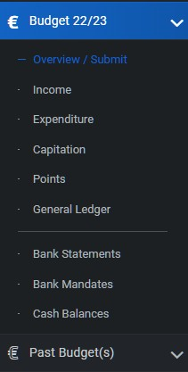The Wolves Budget Section can be found in the left-hand sidebar where you'll get the options shown here:

***Overview*** : Breakdown of your Income & Spending, shows your ***ratio of income/expenditure***

Income : Allows you to input entries to log any money that goes into the C&S account.

Expenditure : Allows you to input entries to log any money that has left the C&S account.

***Capitation*** : This is where you ***draw-down*** your ***capitation*** (budget), shows any ***capitation requests*** & ***special apps requests*** you've submitted.

***Points***: Ties in heavily with your ***Budget Submission.*** Essentially good boy points for good club/society & treasurer practices.

### OVERVIEW : INCOME & EXPENDITURE RATIO

One of the most important things you need to know about being Treasurer is found in the ***Overview*** section of wolves. Here you'll find your income / expenditure ratio. This is something worth keeping track of throughout the year as by the end of the year, you'll have want to ideally have a ***50% ratio***. What this means is that for all your expenditure so far, you've raised 50% of that value. If this ratio is high (>80%) that means that the club/society is covering most of it's own costs with fundraising, and so you're not asking for as much of a budget next year. It will generally say "you're only asking for X amount of your current Y capitation next year". You'll need to spend more and add more expenditure items to bring this ratio down. If this ratio is low (<40%) you're asking for a lot more money from your budget than you're fundraising yourself - so you'll need to make and add more income to Wolves.

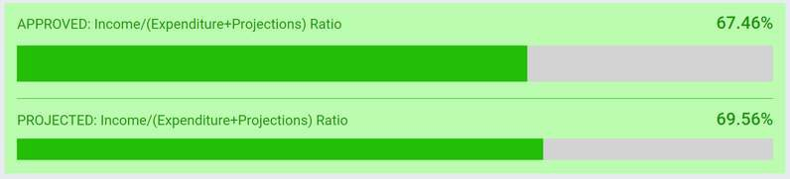

### INCOME

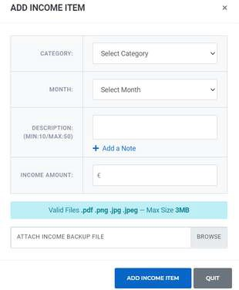The income section of Wolves is where you put in all your income, pretty self explanatory right? ***Membership fees*** are ***automatically entered*** as income items ***when paid by card***. Any other source of income, ULIV entry fees, pub quiz entry fee, member contributions for an IV or event, etc. should be entered as income items on Wolves. ***I'd always highly discourage you from taking cash if you can***. The best way I found to handle cash was to keep the cash and transfer the amount to the club/society account with either bank transfer or Revolut.

### ENTERING INCOME ITEMS

So when you go to enter an income item, you get a pop-up like shown here on the left. First you need to categorize the item, most of these are self-explanatory. Most items will be fundraising, you'll know if it's money collected for charity or gotten from a sponsorship. You need to be very careful with the 'once-off' category. This is ***ONLY*** to be used for something like money made from selling equipment, this money is only coming in the one time and will not be a yearly occurrence. Everything else here is self-explanatory, what month did the money enter the account, give a short description of what it was from and then how much was it. Finally, and most importantly - you need ***proof*** that this ***money entered the account***.

This can just be a e-statement from Banking Online - with the income item highlighted, that's

all it needs to be.

Everything else here is self-explanatory, what month did the money enter the account, give a short description of what it was from and then how much was it. Finally, and most importantly - you need ***proof*** that this ***money entered the account***. This can just be an e-statement from Banking Online - with the income item highlighted, that's all it needs to be.

***INCOME CATEGORIES***

* **Sponsorship –** Income made from a company sponsoring a C&S event. This can be in the form of a monetary donation or a product donation. This income will be projected for the following year.
* **Once Off –** This income will NOT be projected for the following year. This will be used rarely.
* **Charity –** This is income that your club/society raised for charity and not for the club/society. This will NOT be projected for the following year.
* **Special App –** Use this function when your club/society has received funds from the special application. This will NOT be projected for the following year.
* **Personal –** This will be the most frequent form of income. For example, money given by the members directly to the club/society for membership fees or their contribution towards a trip.
* **Fundraising –** This is money raised from a fundraising event. For example, a bake sale, karaoke, or a quiz night. This income will be projected for the following year.

**\*\*NOTE\*\*** If an income entry is rejected for any reason, it will be highlighted in red and a comment will be left by the office explaining why. You will not be notified of this so keep an eye out. If you have any questions about the rejected entry, pop into Lisa and Jana. 8

### EXPENDITURE

So again, expenditure is where you enter all the money that the club/society spends. The expenditure page gives you a total expenditure for the year and a total projected expenditure for next year. Here you can add current expenditure and projected expenditure. Current expenditure is basically any money spent throughout the year, depending on how you categorize this income, it will also be projected as spending for next year. Projected Expenditure is purely projected as expenditure for next year, so this doesn't really tend to get used until the end of the academic year.

### ENTERING EXPENDITURE ITEMS

Again, expenditure has to be categorized - 99% of the time it will be a 'General' item.

* **General** items are just the basic costs associated with running the club and

all of these will be projected to the next year. Most of the other categories

are used pretty rarely, you'll know whether to use these, but you can always

consult Lisa or Jana if you have any concerns.

* **Once-off** expenditure again is to be used very sparingly as this is not

projected for the following year. It’s worthwhile consulting Lisa Ryan if you

ever consider something to be a once-off expense.

* **Capital expenditure** is for items bought for long-term use. For example, a

piece of equipment. Make sure to log these items in Assets & Inventory. This

will NOT be projected for the following year.

Most of the info for expenditure is again very similar to income with the exception of a Ref # for the transfer. For this you can just put in a number like 001, 002, etc. until you have the transfer number once you make the online transfer. If an expenditure item is approved before you can put in the actual transfer reference no. you can attach it as a note.

Instead of proof of income, you'll need to attach a pdf or a photo of the receipt for expenditure items. ***Invoices do not count for this,*** they are a request for payment and do not count as proof of payment. The best thing to do for this is get people to use something like Microsoft Lens to scan any physical receipts to make a pdf which they can email to the club/society email. You just need to make sure there's confirmation of payment on any digital receipts, getting other X clubs/societies to include their bank details with a payment received XX/YY/ZZ date for IVs should be good. I'll talk more on handling receipts in a later section on ***Good Treasurer Practise***.

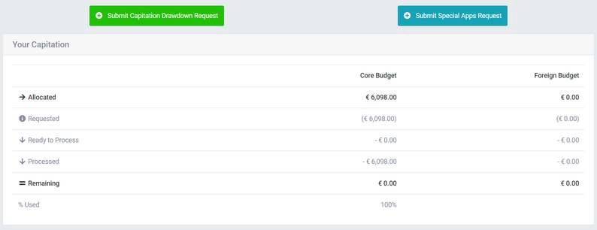

***CAPITATION***

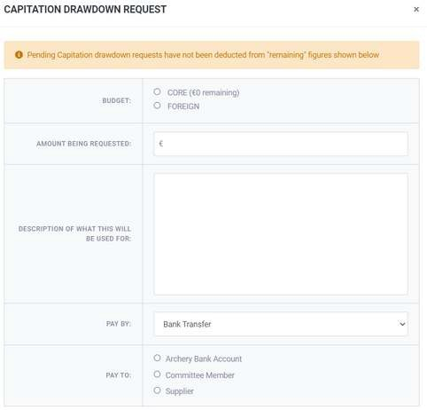Capitation is basically where you can access your budget. At the start of the year, each C&S is sent an excel sheet that contains their allocated budget for the year. Now this money doesn't magically make its way into the X account at the start of the year. To use your assigned budget, you need to make a ***capitation drawdown request***. A capitation request can be used in a number of ways. You can drawdown capitation in order to be able to pay for something that is coming up, you can directly pay a supplier using it or you can 'pay the club/society back' for something you've already paid for.

***You cannot request a capitation drawdown for something you haven’t budgeted for/projected in the previous year.***

Most of the form section here is fairly self-explanatory, for 'Budget' you'll only be using Core Budget unless I do something wrong this year. Foreign Budget is allowed to some C&S who don't use all of their budget from the previous year - this is in very special cases and barely comes up. The main thing here is the ***Pay by:*** section. Here you can select either bank transfer or office card. For office card, you'll need to visit ***Lisa Ryan*** in the C&S office to pay over the phone using the card. It can be useful to pay for something large quickly. Any capitation request requires two signatures from committee to be finalised.

X Bank Account - Money goes directly into the X Account.

Committee Member - Money goes directly to a committee members bank account. Supplier - Money goes directly to the supplier's bank account, upload an Invoice/receipt .

### SPECIAL APPS

Special Apps is essentially like an emergency fund that's available for all C&S. If you have a budget, you can ask for 50% of the money you need. So, if you need €1,500 to help cover the cost of accommodation, you'd need to apply for €3,000. This is because when applying for Special Apps with a budget, you're expected to raise half the total cost of the application. If you didn't get a budget that year, you're entitled to ask for 100% of the cost.

Special Apps is a €33,000 fund that's there for 'unforeseen' expenses. So this could be the prices of flights going up, or maybe the accommodation cancelled and you had to go for a hotel and you suddenly can't cover that increase in cost. It's a very useful resource, but I wouldn't be relying on it every year if you can. This is because you can't project this as income for the following year, it's essentially a once-off income item (although you enter it as under the Special Apps category in income).



Once again, the form that comes up is very similar to a capitation request and does a good job of being self-explanatory. Each Special Apps request goes to the C&S Exec for review, so long as you give plenty of detail in your request, especially when it comes to a cost breakdown there's a pretty good chance it'll be approved. It's good to include as much detail as you can for these with details like:

what is this money needed for

why do you suddenly need this money

how would it benefit the club/society to get this money

if needed for an event to reduce the overall cost for members, how much would it be for members without Special Apps vs. with Special Apps.

These are all things you should be thinking about. It's best to put yourself in the shoes of someone on Exec who is reviewing these, if someone was applying to you looking for

€1,500 in order to run an event, what kind of information would you want to see? Like capitation, Special Apps requires two signatures from committee, best to have signatures 11

from people who didn't write the application.

## THE BUDGET

Every year the X Club hopes to be allocated a budget from UL Wolves C&S. If a budget was not submitted the previous year, the X Club or Society is not entitled to any budget. So the budget is an ***extremely important task*** every year if we want to continue functioning as a club/society. The budget you are allocated depends on a couple of things: the total expenditure and income from the previous year, the ***Budget Points*** awarded for your previous budget and how much of a budget UL Wolves C&S has. The budget provides us with about €5,500 - €6,000 each year that when mixed with our own fundraising, gives us close to €10,000 of funds to spend each year.

## BUDGET POINTS

So I've already mentioned how the ***income/expenditure ratio*** plays a part in your budget submission, you raise too much income - you show you don't need as much of a budget, you raise too little - you show you're not fundraising enough (relying too heavily on C&S). One of the big ***points*** (hee hoo) that determines your budget for the next year is the budget points system. This is basically like a 0-100 scale, 100 points you get your full budget allotment next year, anything below that and you're essentially missing out on money.

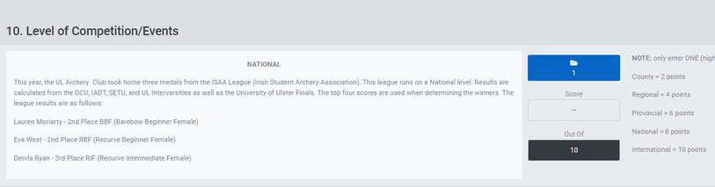

***Budget Points*** as mentioned previously are like a reward system for good practises. The Points section on the Wolves website gives you a breakdown of all the things that earn you budget points. These range from things you do ***throughout the year*** like ***attending C&S Council***, ***attending the C&S Fairs***, ***engaging with the budget*** (adding income/expenditure items) throughout each quarter, ***attending workshops*** and ***taking committee meeting minutes.*** A lot of points are also earned at the end of the academic year when submitting the final budget. At the bottom of the point’s page is an approx. half of your earnable points that require you to upload documents to show proof of the likes of publicity, club/society performance, event frequency and level of competition & events. ***All of these sections need to be filled out prior to submission of the budget.*** This should be delegated amongst the committee, ***the budget is not your sole responsibility, it is a team effort but you need to take lead on getting it organised***.

12

**Projected Expenditure**

This is how you get the club more money the following year. These are new expenses that club has

not already budgeted for, i.e. new weekend trips, higher subsidy on training etc. You input them into the online budget in a similar way as general expenditure, however once in the ‘expenditure’ tab you select projection instead of ‘general’. You then input what the expense is and how much it cost.

As this is projected expenditure you will need to get a quote off the supplier for how much this

expense will cost and take a screenshot of the price. In a separate document copy the screenshot

and its related ‘E’ number onto the document and write a short paragraph of why the club needs the

extra money for this expense. Upload the quotation and justification as the supporting document.

## BUDGET SUBMISSION

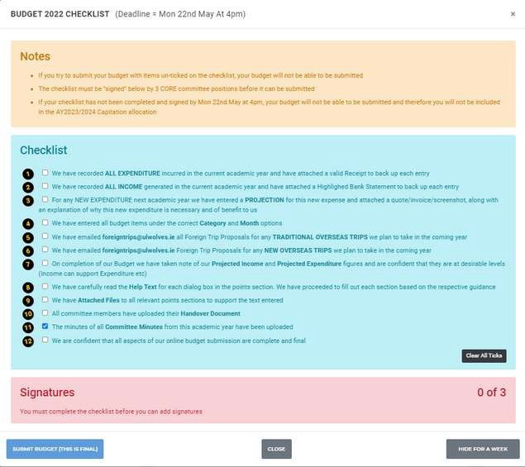While I don't think it's the same date every year, budget submission usually falls sometime in May. To be ready for this date, a number of things have to be done. Thankfully these are outlined in a budget checklist which will show up once the 30 day countdown to budget submission starts, this can be found on Wolves.

As Treasurer, you will need to make sure all expenditure and income has been recorded with valid receipts and proof of income. All projections must be made for the next year before submission of this years budget, failure to do this could result in a budget that doesn't grow to meet the need of the club/society. You also need to check all the budget items are marked under the correct category and month. It is also a good time to make considerations for any foreign trips or big events that may happen in the next year, how will these be paid for? Lay out a plan for things like this now, figure out how much you're going to need to fundraise and save yourself the stress and hassle later. These are all things that will need to be projected to next year - we need a venue for a two day event - okay well we're going to need a substantial fundraiser to pay for that - we can do this during this time

- and so on.

Ensure all the supporting documents for the points section have been submitted, double check they all meet the criteria specified. Ensure all committee handovers have been

submitted as well as all the minutes from committee meetings. ***Final submission of the budget is really a core committee job***, get the President, Captain & Secretary to give 13 you a hand with final submission and it should be much lighter work.

## TIPS & TRICKS

A lot of being Treasurer is experience and making mistakes and learning from them, no matter what you do, you're going to make a mistake as the Treasurer at some point. That's fine [as long as it's not during final budget submission >:( ], but it helps to know a lot of the mistakes and pitfalls that you can fall into. This section is just going to be bullet points on some topics that are good to be aware of.

#### Handling Receipts

Tell everyone to use something like Office Lens to allow them to send pdfs of receipts to the club/society email. PDFs are much cleaner, more organised and easier to read for the C&S office.

Make use of labels on the club/society gmail account, you can customise these however you see fit.

Personally I made use of a "Treasurer" tag for anything involving me.

"Receipts" for tagging any receipts that I haven't looked at yet

"Logged & Unpaid" for receipts entered on Wolves but not repaid through BOI Online

"Logged & Repaid" for receipts logged and paid back. "Invoices" for tracking any invoices

#### Capitation

Make sure to withdraw all your capitation by the end of the year otherwise it will be lost. Best to use capitation to "repay" the club/society for expenses. After a couple large expenses, compile the receipts and make a capitation request to recoupe the losses out of the club account.

It can be useful to use captiation to pay for really large invoices - it's probably quickest to do this through the office card if ***Lisa is available,*** but remember you need to go into her to make the transaction, nothing will happen with just the captiation request.

#### General Spending

If anyone is planning on spending club/society money, they should make you aware of it. Making club/society purchases without consulting the Treasurer is just poor practise, it makes your job harder by disorganising your hard work of budgetting our money.

This is somewhat alright for smaller items, but even a simple "can I spend €40 on prizes" is much better than just finding a bunch of receipts on the email without any knowledge of where they came from.

You should always pay back people back for purchases, but you are not bound to pay someone for something they bought without club/society consent.

#### Club Gear Orders

If putting in a large order for club/society gear - likes of jerseys, jumpers etc. it's alright to take cash from members since you'll have such a large amount of cash notes.

Example - our jumper order this year came to about €3,000, majority of the money collected from members was in the form of cash. It's a lot of cash to have in the moneybox so you want to deposit it as soon as you can, but its much easier to lodge that amount than trying to lodge petty cash and change.

#### Revolut

Revolut is honestly a godsend as Treasurer, your first Treasurer update should include recommending everyone on committee to pick it up, it makes small payments so much easier than handling change and cash.

Revolut's Vault feature is absolutely amazing, I only started using it late into my time as Treasurer but it made managing club/society money on my account much easier.

If you take any club/society money into your personal Revolut, make a vault - so maybe a UCC entry fee vault where you send any money that comes into your account from members.

Vaults help you separate club cash from your personal cash and helps avoid any confusion between the two.

#### IVs, Other Colleges and our Own

Don't pay for IVs in cash - do a bank transfer on Wednesday/Thursday, Friday latest and send them an email saying the money is sent on - if too late, use your own Revolut, ***DO NOT USE CASH FOR IVs.***

Be an absolute hound about getting receipts back from other colleges, it's always IV receipts we're waiting on every year.

For our own IV, make up a spreadsheet using the shooting list to track all the colleges attending and how many are attending from each.

A website like https://invoice-generator.com/#/1 can make both invoices and receipts for our IV, your shooting list spreadsheet should make it really easy to track how much needs to be charged to each college.

Try give other colleges much notice and opportunity to send on their entry fees, if they show up willing to pay Revolut or with cheque that's fine.

If a college has paid through bank transfer but the money hasn't come through yet, it's best to ask for a deposit over Revolut that can be returned to them once the money comes through.

#### Handling Cash

Discourage cash use at every possible opportunity.

Don't take cash for member contributions - use Revolut or bank transfer.

Don't take cash for anything if you can do it electronically - cash is not king, cash is cringe - at least in C&S banking.

Cash without a physical receipt is traceless, there's no way of proving cash was transacted without a receipt, so even just using Revolut is a million times better as you at least have proof of transaction.

If you have to take petty cash for something, it's usually easiest to record it, pocket the cash and transfer the equivalent via Revolut to the club/society account.

#### Club/Society Bow Kit Deposits

The deposit for bow kits is currently €75, we used to only take this deposit in the form of cash which would be stored in the moneybox.

What I did this year was take deposits in whichever form and then log the money into a

***Revolut Vault***.

Again, this just allows you to separate out the money from your own account and makes payback of deposits easy through Revolut transfers.